**Grand plan to start Digital Clothing company**

With the correct strategy, my ambitious idea to transform the fashion business into a digital clothing company is both doable and realistic. My goal is to develop an online platform that allows users to edit designs and see them in three dimensions. To do this, I'm going to set out to become a premier IT specialist.

1. Foundation in Web Development: To construct the front end of our website, begin by learning HTML, CSS, and JavaScript. If I want a dynamic user interface, I’ll check out frameworks like Angular or React.

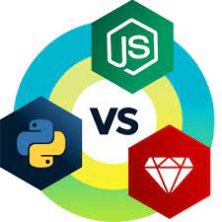

2. Complex Coding Systems: To manage server-side tasks, become proficient in backend technologies like Node.js, Python, or Ruby on Rails. Gain an understanding of databases (MongoDB, SQL) for effective data management.

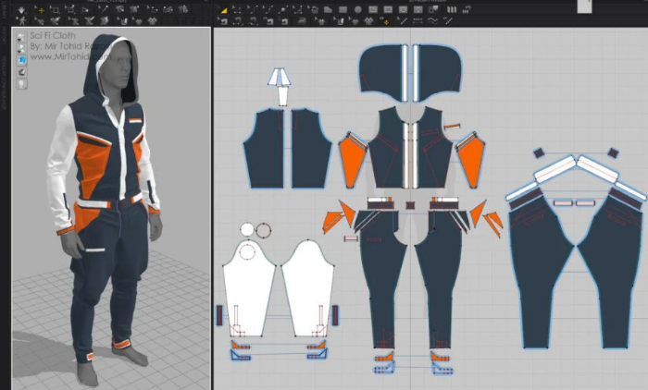3. 3D Modelling and Visualization: Learn about 3D graphics by building and displaying 3D models with frameworks like Blender and Three.js. Investigate AR and VR technologies for a captivating consumer experience.

4. Newest Innovations: To incorporate intelligent customization features, stay current on AI and machine learning. Transactions using blockchain technology can be transparent and safe.